

Candidate Exam Handbook
2026/27

This handbook is reviewed and updated annually
Produced/reviewed by
Ms Jarvis
Date of next review | November 2027

Introduction
Glenwood School is committed to ensuring that candidates are fully briefed on the exam and assessment process in place in the centre and are made aware of the required JCQ/awarding body instructions and information for candidates.

This handbook is for both parents and pupils to explain our exam procedures and contains all of the information you need to know to successfully sit examinations at Glenwood School.

Malpractice
Malpractice is another word for cheating or breaking the rules. You are not allowed to cheat in your examinations as this would not be fair.
If you are suspected of malpractice then we have to investigate and report what happened the exam boards.
Examples of what could be malpractice are:
- Breaking examination rules like talking in the exam or bringing a mobile phone into the exam room.
- Copying the work of another pupil.
If you want more information about what could be classed as malpractice you can ask your teachers.
You must also be careful about how you use social media as misuse could also be malpractice.
Things not to do on social media:
• Buy/ask for/share exam or assessment content
• Pass on rumours of what’s in exams or assessments
• Share your work
• Work with others so that your assessment is not your own independent work

and/or non-examination assessments and coursework, as example:
Research and using references
- Where computer-generated content has been used (such as an AI Chatbot), your reference must show the name of the AI bot tool used and should show the date the content was generated. For example: ChatGPT 3.5 (https://openai.com/blog/chatgpt/), 25/01/2027. You should also acknowledge the sources used by the AI tool in generating the content.
- You must keep a copy of the question(s)/prompts used to generate the AI content and the AI generated content itself in a non-editable format (such as a screenshot) and provide a brief explanation of how you used it. This must be submitted with your work for final assessment so that your teacher can review the work.
If you copy the words, ideas or outputs from other sources and do not show your sources in references and a bibliography, this will be considered as cheating.
Plagiarism
Plagiarism involves taking someone else’s words, thoughts, ideas or outputs and not crediting the source. This includes outputs from AI tools. Plagiarism is a form of cheating which is taken very seriously.
There will be posters up in the exam room and outside to tell you what the rules are. Your teachers will go through this with you before the exams.

Personal data
We have to share your personal data with the exam boards in order to register you for exams.
This can include
- Your name, date of birth and address
- Your unique numbers which we use to identify you in school (UPN, UCI, ULN)
- Information about your learning needs
- Candidate notice and opt-out
A candidate may notify the awarding body, by giving notice to the centre, that they wish to opt out of the awarding body’s use of their Student Materials for the purposes set out above.

To understand more about what information is collected and how it is used, you must read the JCQ Information for candidates – Privacy Notice (a copy of this is being sent home with this handbook)

Copyright
When you produce work for an exam, either course work or in an actual examination that work belongs to you.
By submitting your work you give the exam board you give them permission to use it.
If you wanted to you could ask them not to use it after it has been used to assess you. To do this you need to ask Ms Jarvis to do this for you.

Coursework assessments/non-examination assessments
In some of your subjects coursework is used towards your final exam grade.
For example in Food Technology, Art, Music, Humanities and PE.
Coursework is marked by your teachers and then your teachers marking is checked to make sure they have been fair. This is called Quality Assurance.
Samples are then sent to the exam boards so that they can also do some quality assurance to make sure you get the correct mark for your coursework.
Sometimes your teachers can tell you how well you have done in your coursework before it is sent off to the exam boards, if you want to appeal this grade you can do so.
Your teachers for each subject will make sure you know any rules about how your coursework needs to be produced and the dates it has to be completed by.

Written timetabled exams
At your Annual review you will be given a list of which exams you are being entered for.
You will get a timetable which tells you when your exams are for GCSE exams.
For Entry Level Certificate Exams and tasks you will be told by your teachers when the assessments will happen.
If you are worried about what exams you have been entered for then please talk to Mrs Williams, your form tutor or your subject teacher.

Contingency day
Every year there is an extra day after GCSE exams have finished which is used as a contingency day.
This day will be used to finish any exams which have been cancelled. Exams might be cancelled for lots of different reasons. For example if the school had to close on an exam day because of snow.
The contingency day is on 23rd June 2027, please do not book any holidays or activities on the contingency day in case it is needed.

Where you will take your exams
Exams usually take place in the main hall.
If you need a reader or a scribe for your exam then you will be in a private room. This could be the nurture room, meeting room, an office or a classroom.

Supervision during your exams
Exams are supervised by Invigilators.
These will be staff that you know.
Invigilating staff have to follow strict rules and regulations about how to conduct the examinations.
They are also there to help you, if you have a question you can put your hand up and someone will come and talk to you.

Exam room conditions
BEFORE THE EXAM:
You should always try to be a few minutes early for your exams. We will provide a classroom and offer you a drink and something to eat prior to your morning exam.
You will be escorted to the exam hall by a member of staff and asked to line up outside the exam room quietly. There will be posters up to remind you of the exam rules.
As soon as you are asked to come in to the room you must be quiet and follow the exam rules.
You must not write inappropriate, obscene or offensive material.
Bags, coats, mobile phones, headphones, ear buds, MP3 players, watches, smart glasses, and lunchboxes must be left outside the exam room.
You may bring a clear pencil case containing pens, pencil, a rubber and ruler. If you need any special equipment like a calculator or a dictionary this will be provided for you.
You should sit at the desk with your name on.
Do not write anything on the exam paper until asked to do so.
DURING THE EXAM:
You are under formal exam conditions as soon as you enter the exam room, you must not talk to or attempt to communicate with or disturb other candidates once you have entered the exam room.
You may not leave the exam room without permission from the invigilator, even at the end of the exam.
You must not talk to any other pupils once in the exam room or do anything that disturbs anyone else.
The start and finish time of the exam will be displayed on the wall along with the centre number and more exam rule posters.
You must write clearly and in black ink. Coloured pencils or inks may only be used for diagrams, maps, charts, etc. unless the instructions printed on the front of the question paper state otherwise
If you need more paper to write on during the exam then put your hand up.
If you do not understand what you have been asked to do then please put your hand up.
A clock will be provided for you to see the time.
AFTER THE EXAM:
You must stay in the exam room until the time for the exam is up or a member of staff has given you permission to leave. If the exam length is more than 1 hour you must not leave within the first 60 minutes from the official start time of an examination. Your invigilator will advise you of the earliest time you may leave the room if you finish the exam early.
When you are told to leave you should leave quietly in case other pupils are still working. You must leave your question paper on your desk when you leave.
Once you leave you will not be able to return unless you are on a supervised rest break.

Where you will sit in the exam room/How your identity is confirmed in the exam room
You will sit at the table with your name card on. The card will have details of the access arrangements that you are entitled to use during your exam.
If you can’t find your desk you should ask an invigilator.

Using calculators
You can only use a calculator for some exams.
You will be told if you can use a calculator and one will be provided for you.

What you should not bring into the exam room
You are not allowed to bring coats, bags, mobile phones or any type of watch into the exam room.
You are not allowed to wear a watch in the exam room.
If you bring unauthorised items into the exam you may be asked to leave and your exam may be cancelled.

Food and drink in exam rooms
No food is allowed in the exam room. If you need a drink of water during the exam please put your hand up and one will be provided for you. If you bring a water bottle to the exam this must be see through with no labels.

What you should wear for your exams
You should wear school uniform for exams.

Where your personal belongings will be stored during your exam
Personal belongings will be stored in the corridor outside the exam room or in a classroom.

What to do if you arrive late for your exam
If you are late to school for your exam you must report to reception as soon as you arrive. If possible you will be allowed to join the exam late. Additional time will be added if possible.
If you are in school but arrive late for an exam you should report to reception and if possible you will be allowed to join the exam late. Additional time will be added if possible.

What to do if you are unwell on the day of your exam
If you are absent on the day of an exam your parents/carer should report your absence to school in the usual way. A reason must be provided.
If you are absent on the day of a GCSE exam then we will need to inform the exam board of this. Depending on the reason they may ask us to provide other evidence to support awarding you a grade.
If you are ill on the day of a GCSE exam then you should ask your doctor for a medical note to explain this.
If you are absent on the day of an Entry Level Certificate exam then we may be able to rearrange the date.
If you feel unwell during an exam, put your hand up and tell an invigilator.

What happens if you have an unauthorised absence from your exam
If you do not attend an exam and you are not ill or have a reasonable explanation you may be charged an exam entry fee.

What happens in the event of an emergency in the exam room
In the event of an emergency during an exam the invigilators will tell you what to do. For example if there is a fire alarm.
If this happens the exam will continue afterwards if possible.

Candidates with access arrangements/reasonable adjustments
Most pupils will have some access arrangements.
This includes:
25% extra time – This time is added on to the length of the exam to give you more time to write your answers. You do not have to use this extra time if you do not want to.
Reader/Computer reader – This means a member of staff can read the question paper to you or you can use a reader pen.
Scribe – A member of staff can write your answers for you.
Word processor – You can use a laptop to record and then print your work – the spelling and grammar check may need to be turned off.
Access arrangements are agreed at your Annual Review and they have to be your ‘normal way of working’ – if you are not sure what access arrangements you have please ask Mrs Williams or your tutor.

Results
Your results will be available on the National GCSE results day in August.
Details about how to collect them will be sent home in a letter.

Post-results services
After you have your results there is an appeal process if you are not happy and want to find out if your grade was fair or to look at your exam paper and how it was marked.
You need to talk to Mrs Williams about this.
There are fees and charges for some post results services.

Certificates
Certificates will be available to collect during the Autumn term after your exams.
You will be contacted when they are ready.
You must collect them yourself or a parent/carer can collect them. If someone else is collecting them you must give them written permission and they must bring some photo identification.
You will be asked to sign for your certificates.
We can only keep certificates for 12months. Then they have to be shredded.

Complaints and appeals procedure
If you would like a copy of our Complaints and Appeals procedure then please ask Mrs Williams or Ms Jarvis.

JCQ Information for candidates - coursework
You must read this information if you are undertaking qualifications that contain elements of coursework assessment.
This document can be found on our website.

JCQ Information for candidates – non-examination assessments
You must read this information if you are undertaking qualifications that contain components of non-examination assessment.
This document can be found on our website.

JCQ Information for candidates – on-screen tests
You must read this information if you will be taking any externally assessed on-screen tests as part of your qualification(s).
This document can be found on our website.

JCQ Information for candidates – written exams
You must read this information before you take any externally assessed timetabled written exams.
This document can be found on our website.

JCQ Information for candidates – Privacy Notice
You must read this notice as it contains “Information About You and How We Use It”
This document can be found on our website.

JCQ Information for candidates – social media
You must read this information to help you stay within examination/assessment regulations when using social media.
This document can be found on our website and a copy is provided in this handbook.

JCQ Unauthorised items poster
This poster will be displayed outside each exam room. You must note that “Possession of unauthorised items, such as a mobile phone, is a serious offence and could result in DISQUALIFICATION from your examination and your overall qualification.”
This document can be found on our website and a copy is provided in this handbook.

JCQ Warning to candidates poster
This poster will be displayed outside each exam room. You must note all the warnings.
This document can be found on our website and a copy is provided in this handbook.

JCQ AI poster for students
This poster is a quick guide to help you to better understand the rules for use of AI in assessments.
This document can be found on our website and a copy is provided in this handbook.

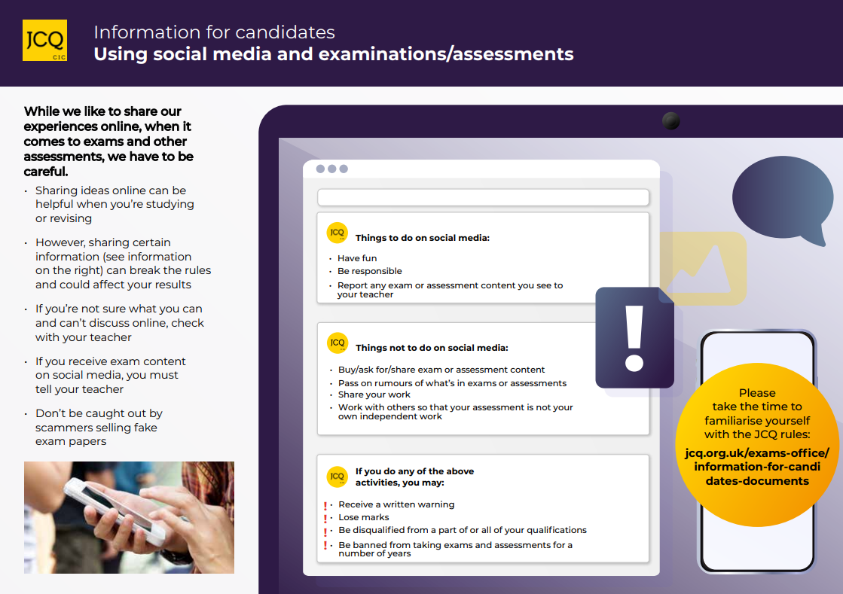

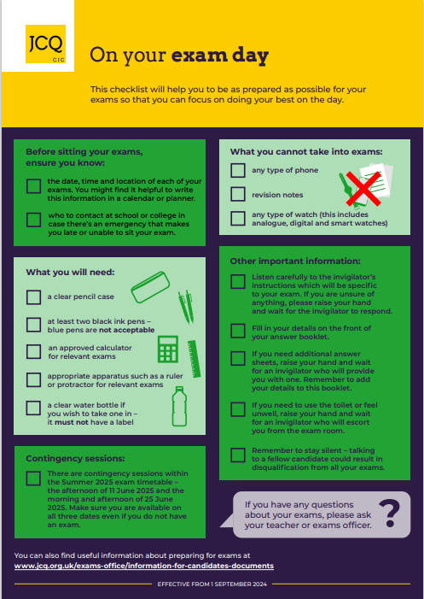

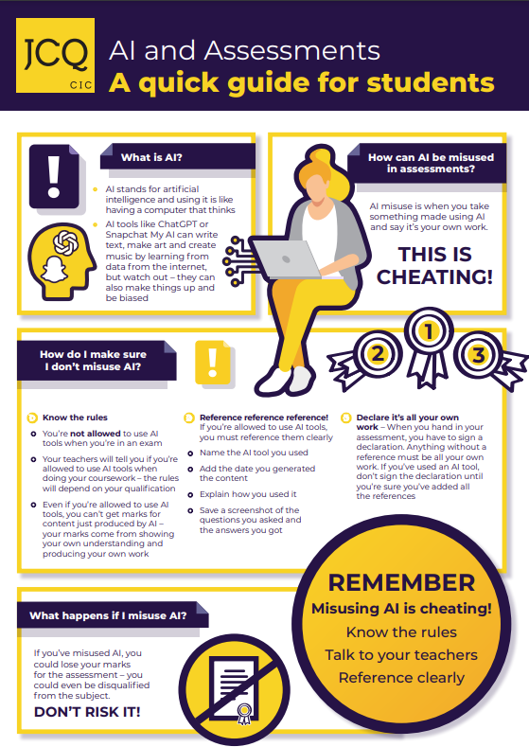



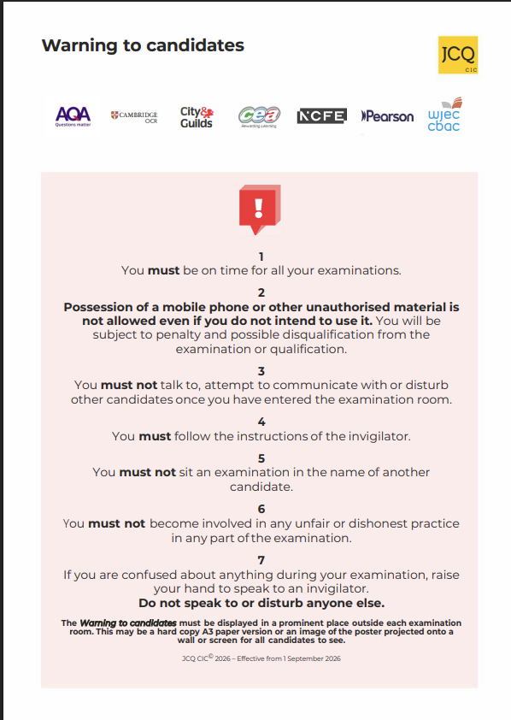

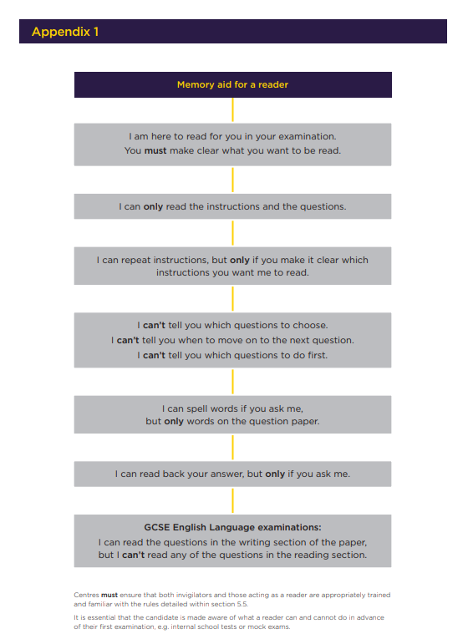

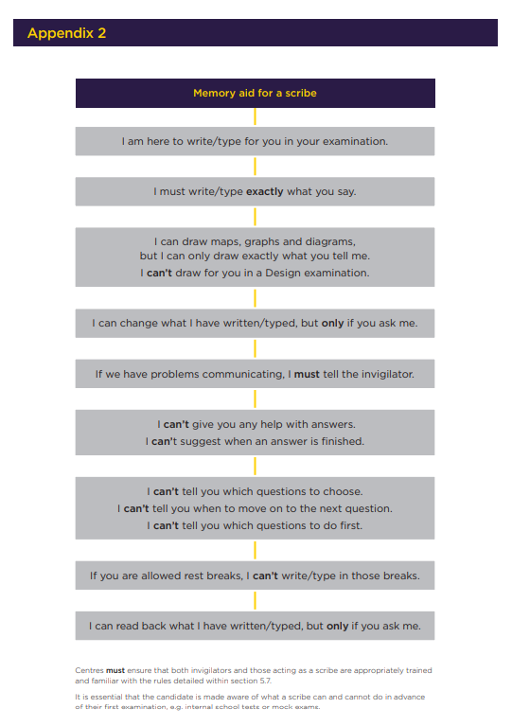

Candidate confirmation
To confirm you have received, read and understood the contents of this handbook, please sign and date the tear-off slip below and return to Mrs Williams by 19th December 2026.
If there is anything you do not understand, you should ask Mrs Williams or your tutor for clarification.

------------------------------------------------------------------------------------------------------------------------------------
Candidate Exam Handbook
NAME: Overwrite your name here
Date I received the handbook: DD / MM / YYYY
I have read the contents
I understand (Tick all of the boxes that apply)
- What constitutes malpractice in examinations/assessments
- What my personal data is used for by awarding bodies
- Copyright
I have read and understand the 2026-2027 JCQ information for candidates documents as they relate to the qualifications I am taking (Tick all of the boxes that apply)
- Coursework
- Non-examination assessments
- On-screen tests
- Privacy Notice
- Social media
- Written exams

By signing here, I am confirming all of the above

Candidate Signature: Overwrite your signature here

Date of signature: DD / MM / YYYY

